Collin College
Allen Technical Campus – KONE Conference Room
2550 Bending Branch Way, Allen, TX 75013 - Building B – B105
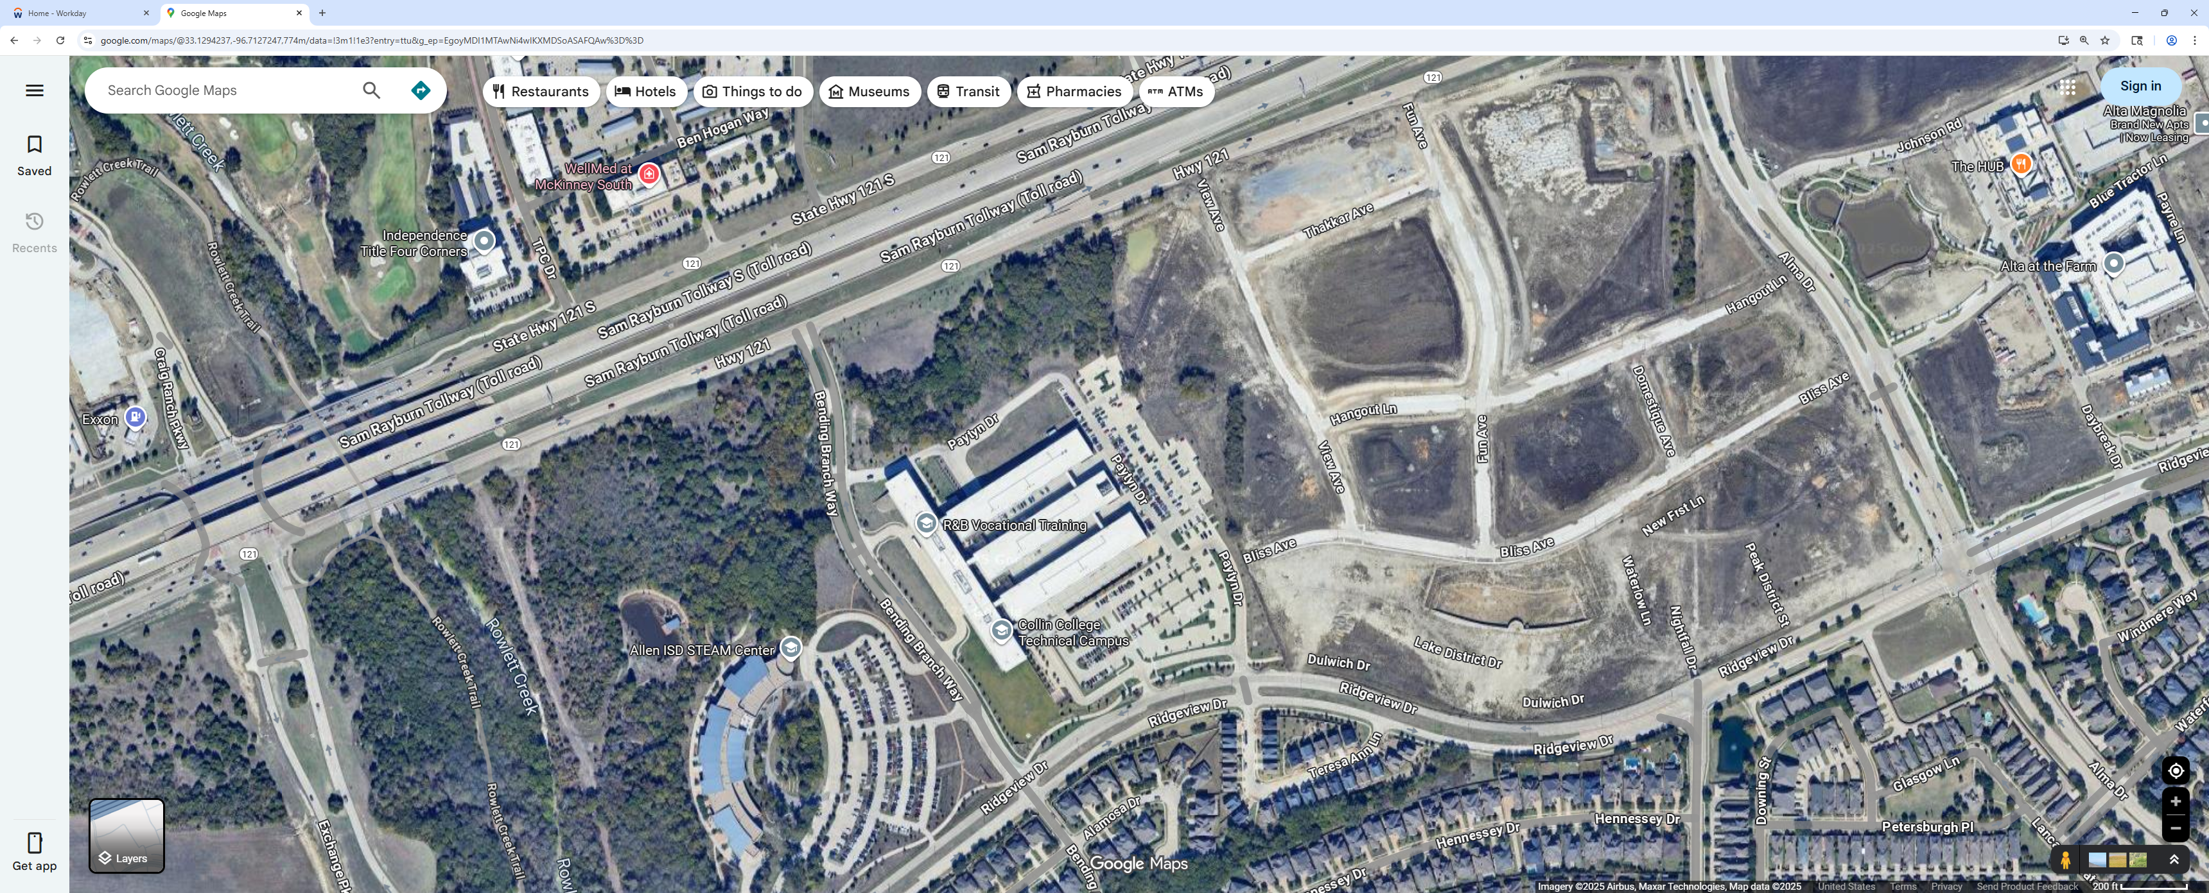
KONE Conference Room B106
Parking

